`
Adored animals!  Find out which is the most popular wild animal. Ask your family and friends to vote for their favourite wild animal.  Think about how to record and present the information. You could use tables, tallies, pictograms or graphs. | Fire Art!  Create your own piece of fire art. You can use any materials and your art could be 2D or 3D. Think carefully about the use of colour and texture.  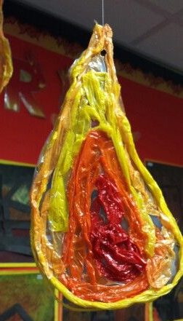  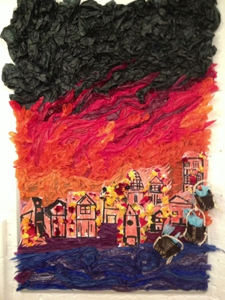
Brilliant baking!  Bake something that Thomas Farriner might have made in his bakery on Pudding Lane. You could share the recipe by writing a set of instructions.  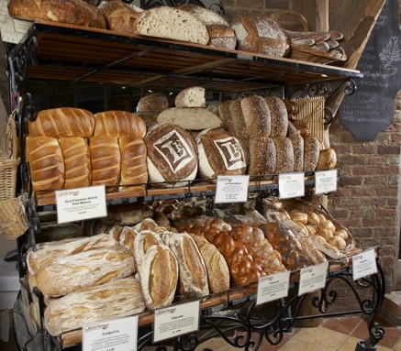 | Animal inventor!  If you could create your own new animal what would it look like? Would you take different parts of lots of animals? What would you call your animal? Would it be a reptile, mammal, fish, amphibian, bird or invertebrate? What would it eat? Would it be a carnivore, herbivore or omnivore? What kind of habitat would it like?  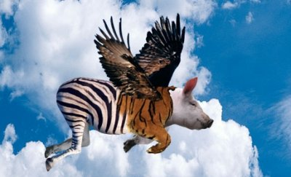
Mask madness!  Create a wild animal mask using junk materials. Think carefully about the properties of the materials you use.  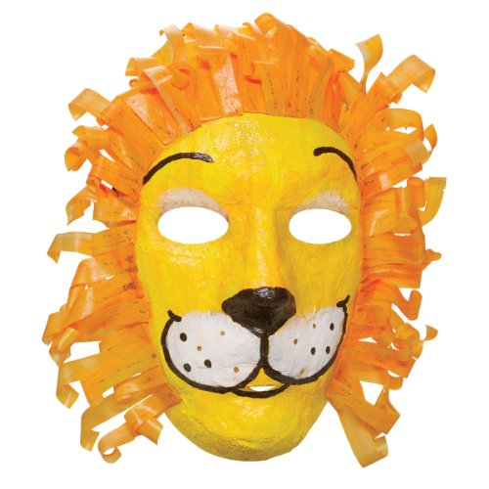 | Super safety!  Create an information poster or leaflet to inform people about the importance of fire safety. You could create a fire poem which teaches people how to respond in the event of a fire.  